**Name:**

**Matric:**

**Course:**

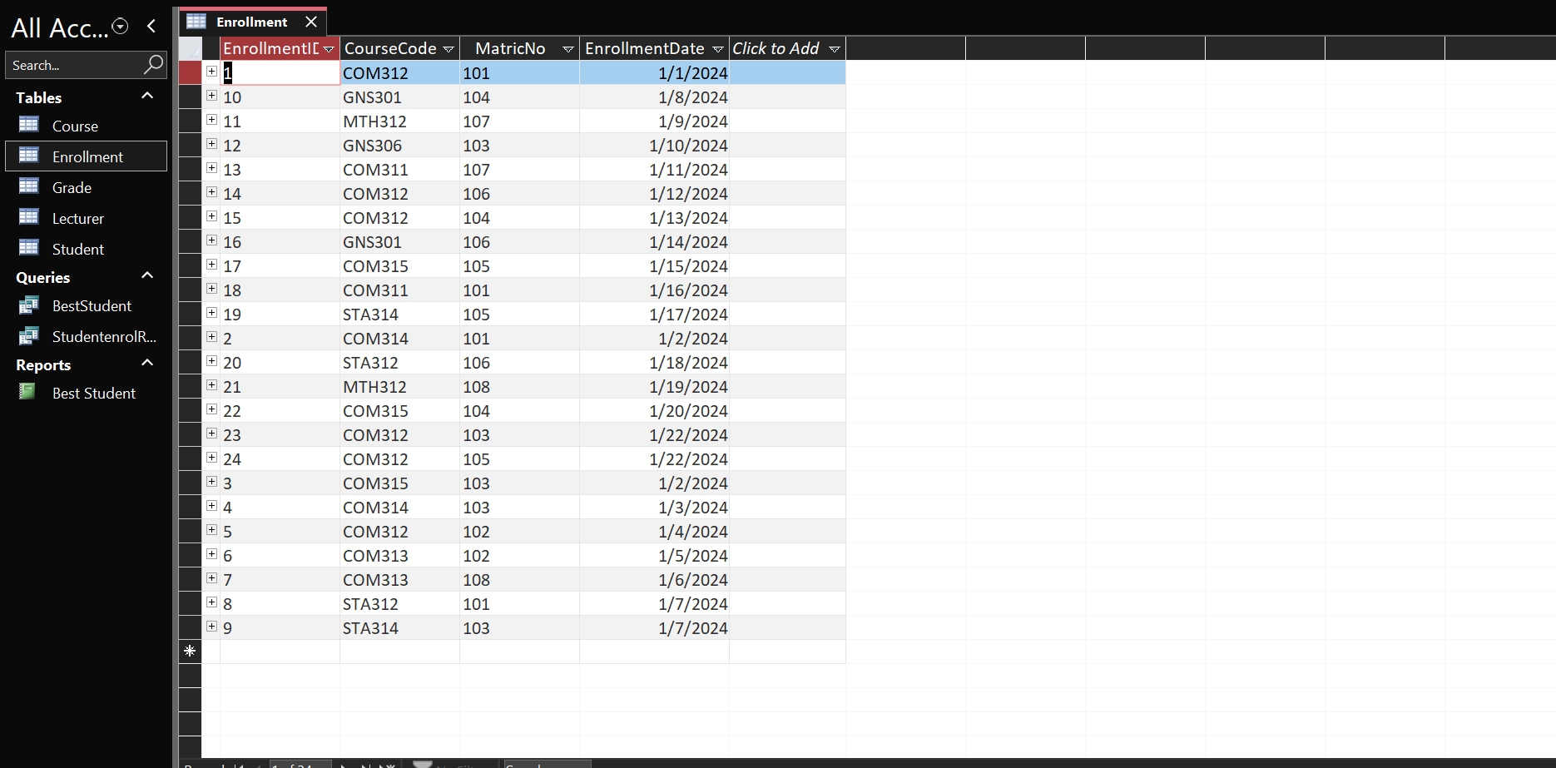**Enrollment Table**

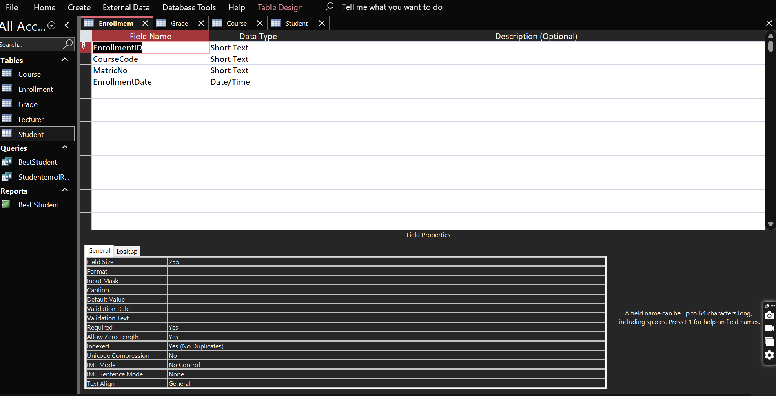Datasheet View

Design View

**Name:**

**Matric:**

**Course:**

**Student Table**

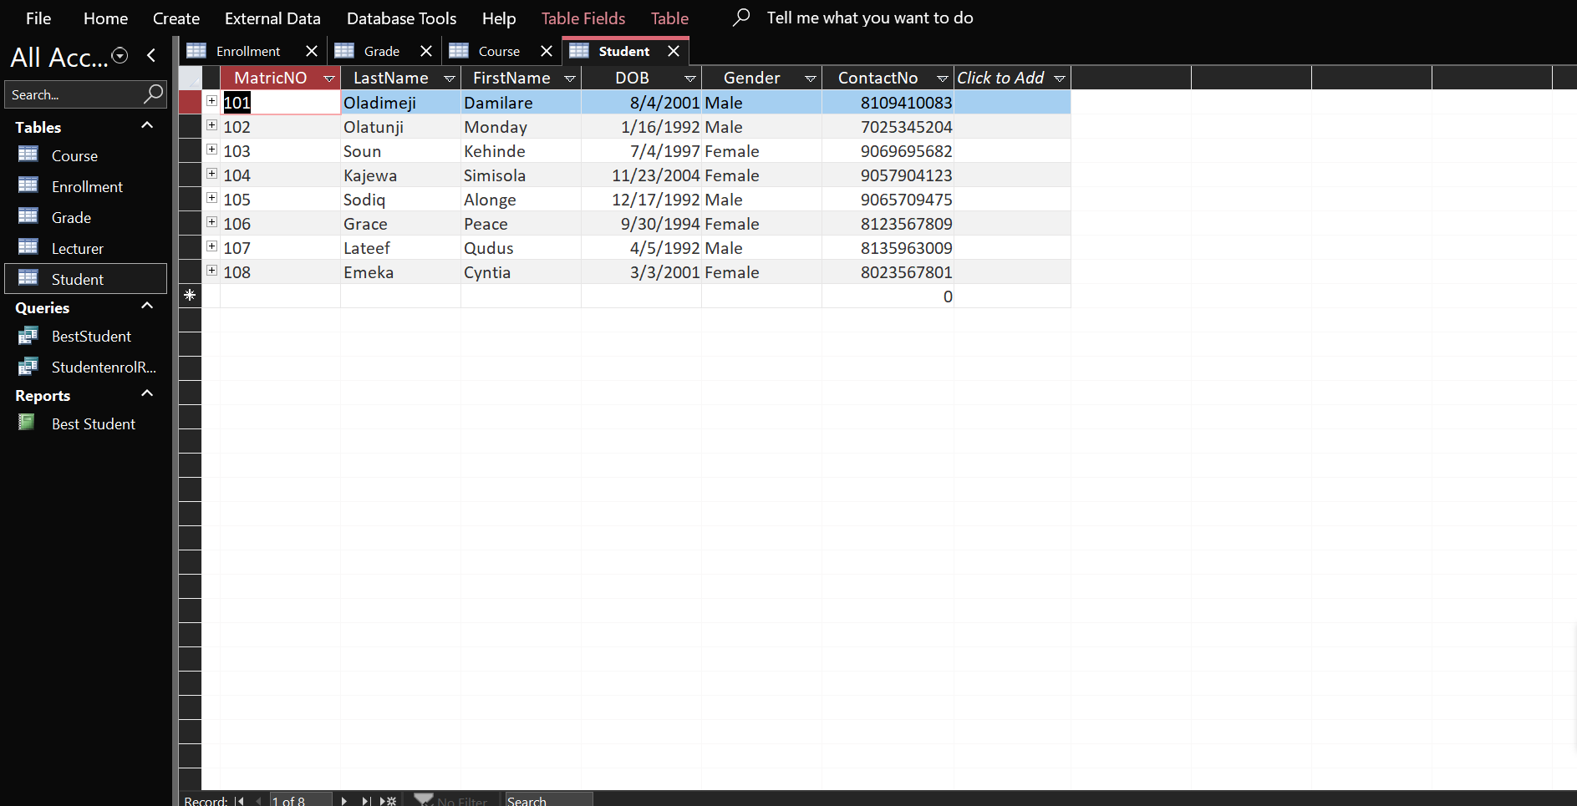

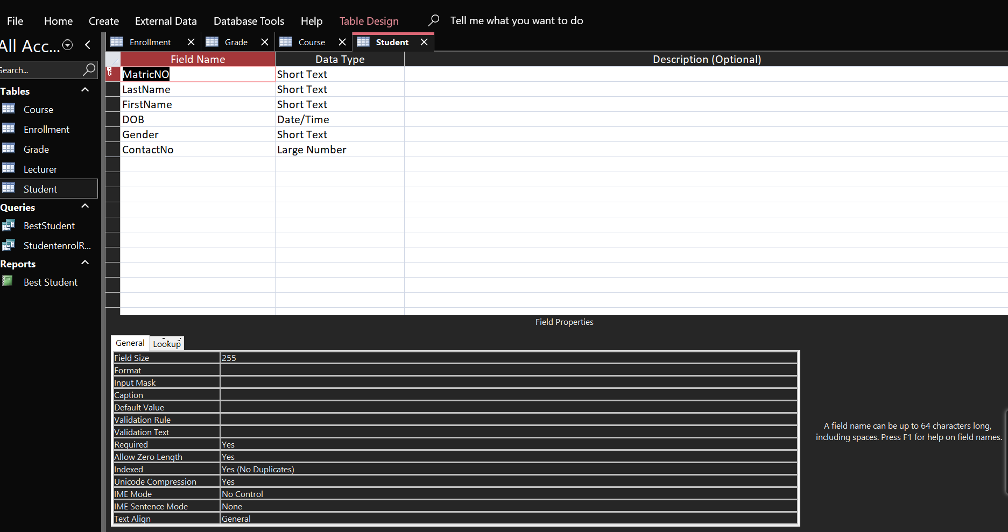Datasheet view

Design View

**Name:**

**Matric:**

**Course:**

**Grade Table**

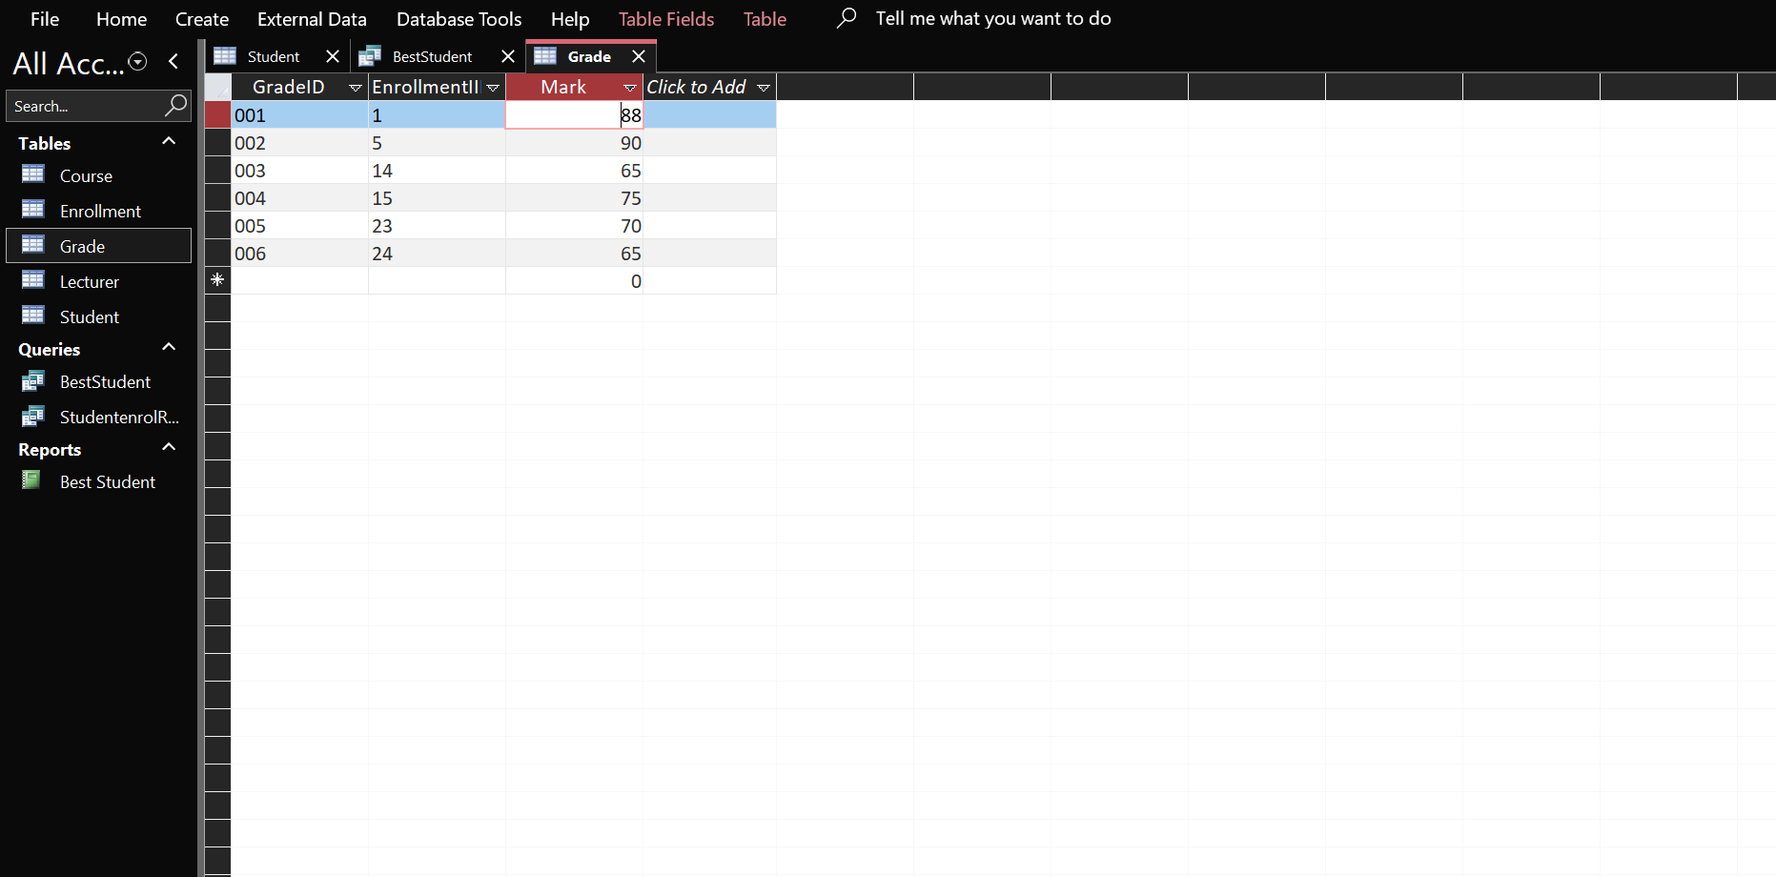

Datasheet View

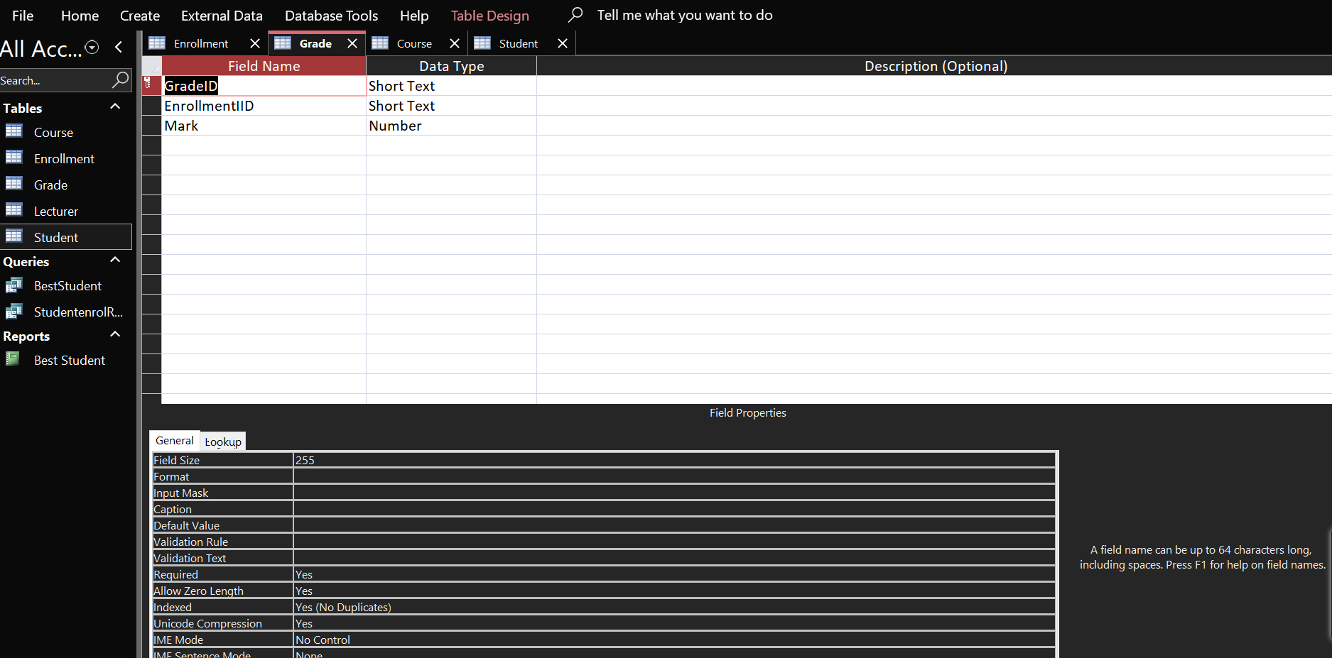

Design View

**Name:**

**Matric:**

**Course:**

**Course Table**

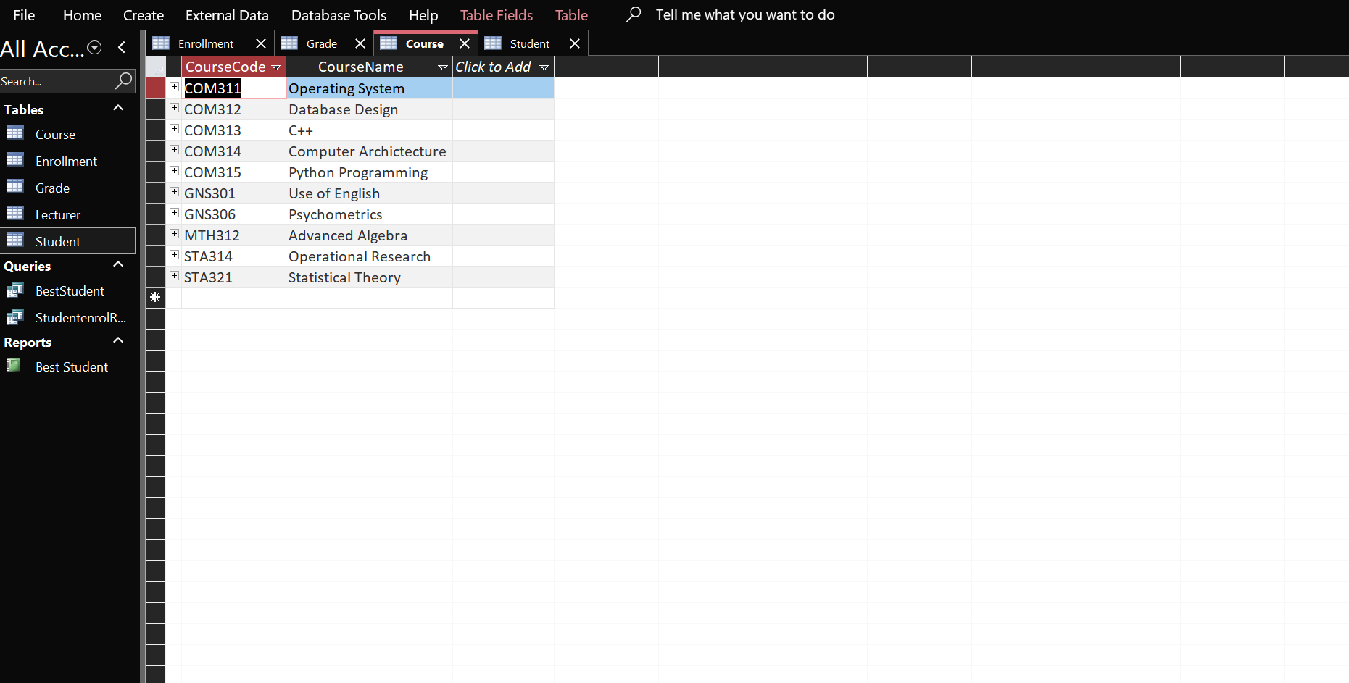

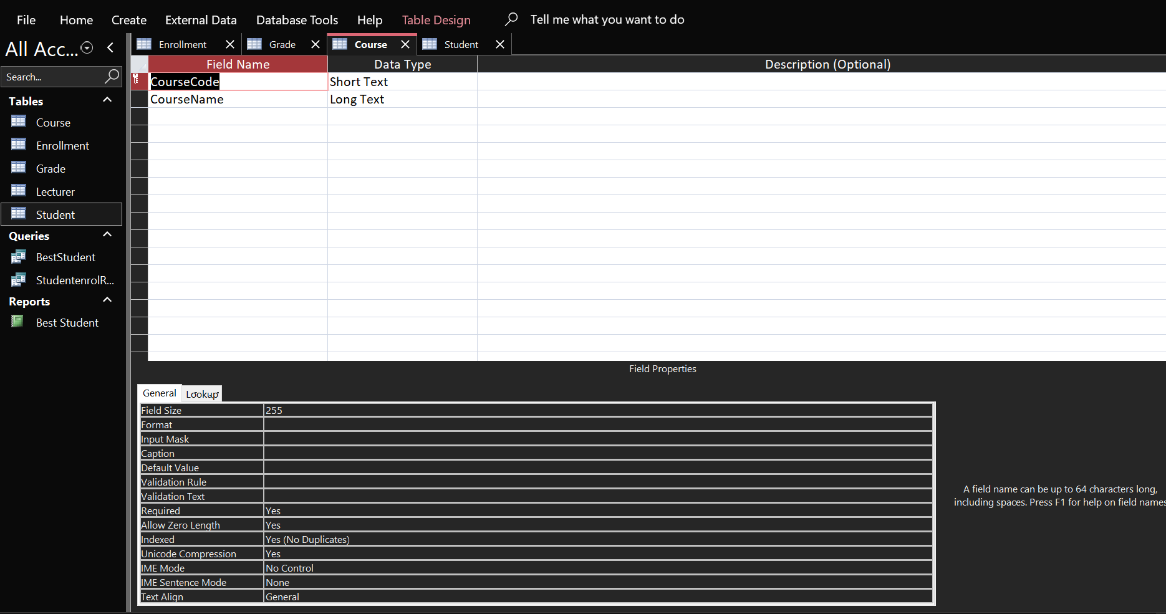Datasheet View

Design View

**Name:**

**Matric:**

**Course:**

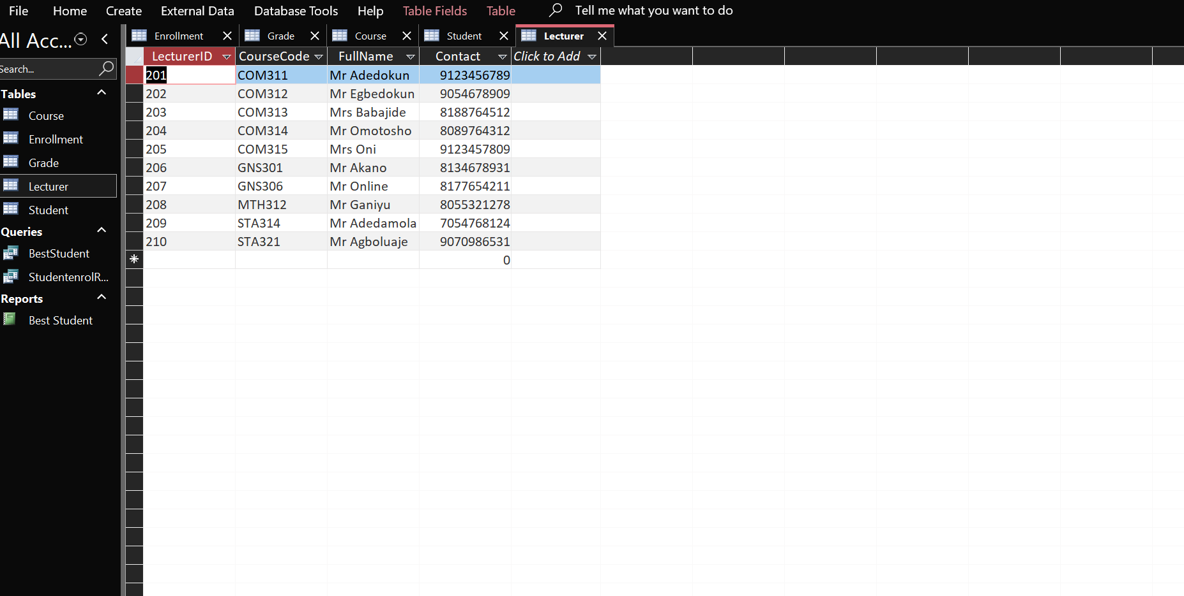**Course Table**

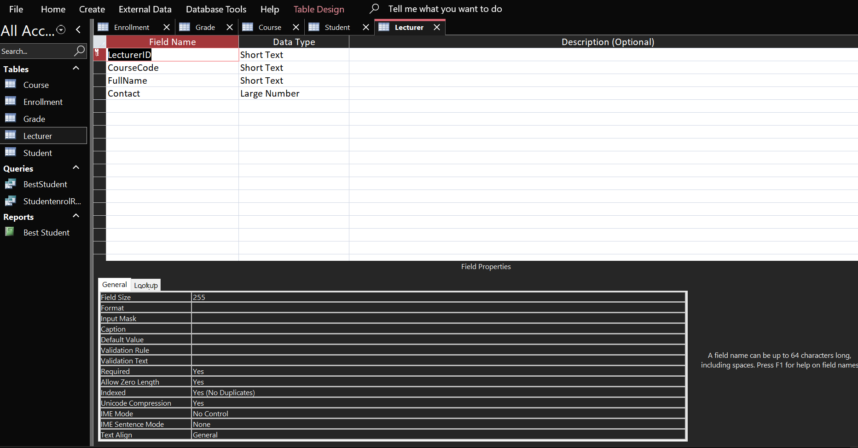Datasheet View

Design View

**Name:**

**Matric:**

**Course:**

**Query for Course with the least number of student Enrollment**

**Design View**

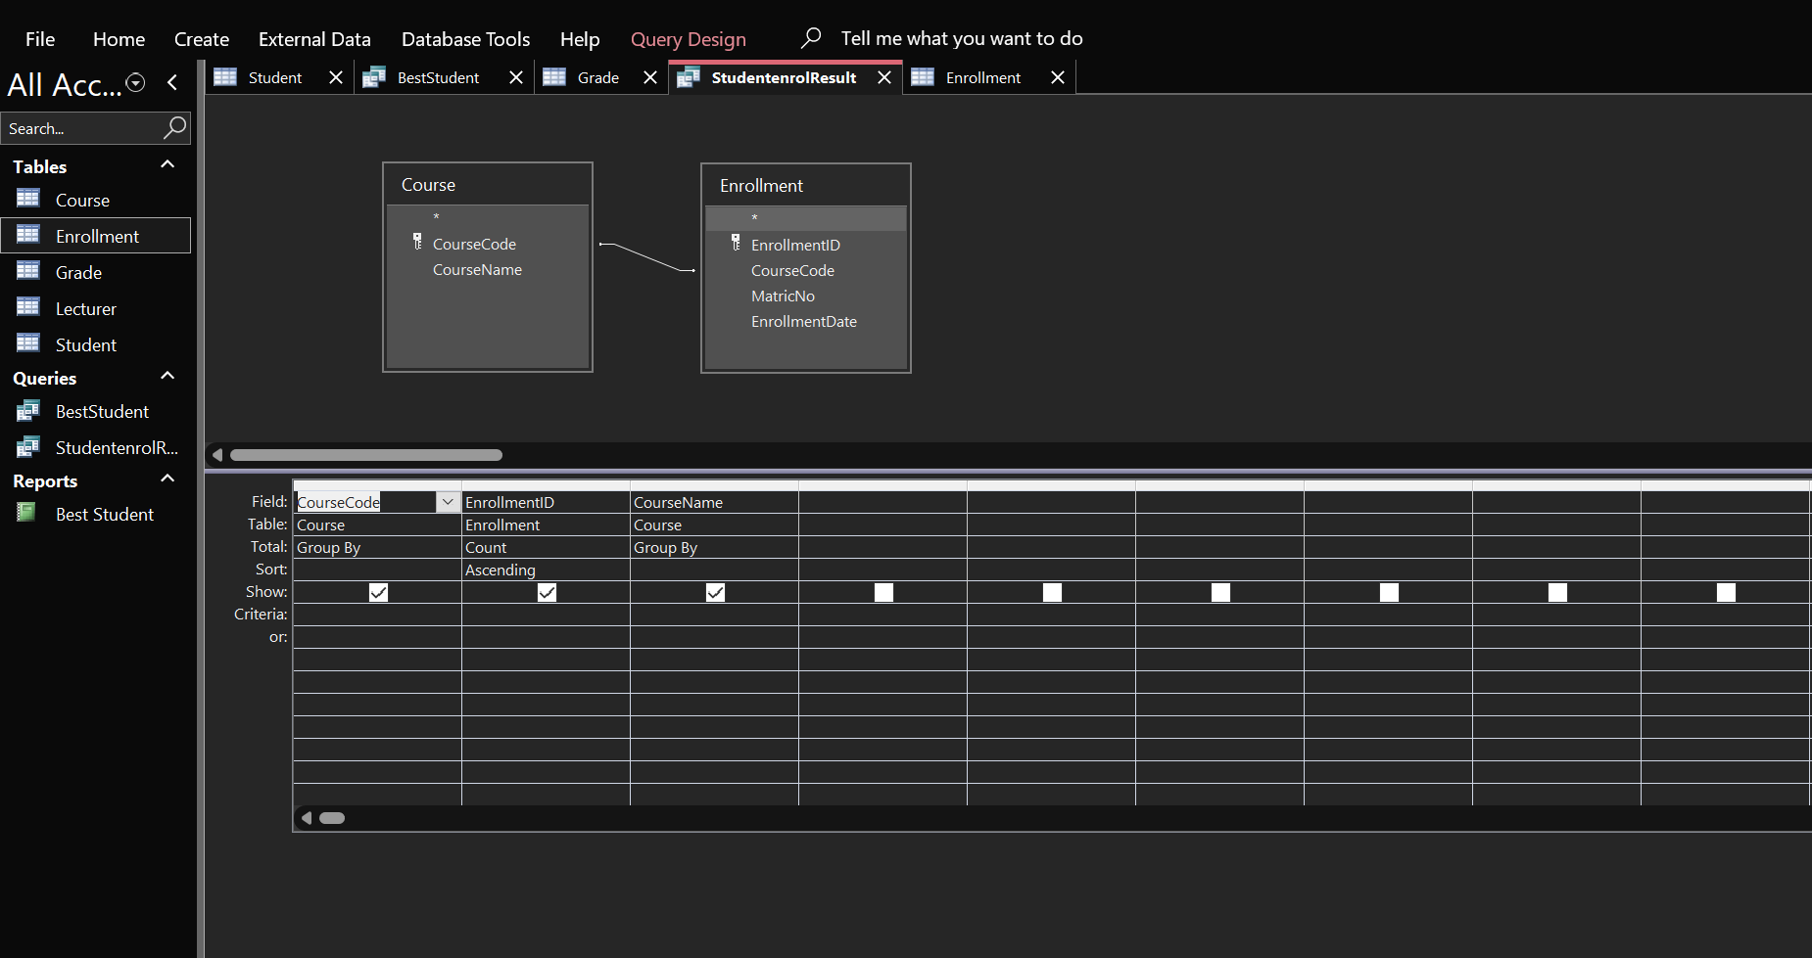

**Datasheet View (Output)** 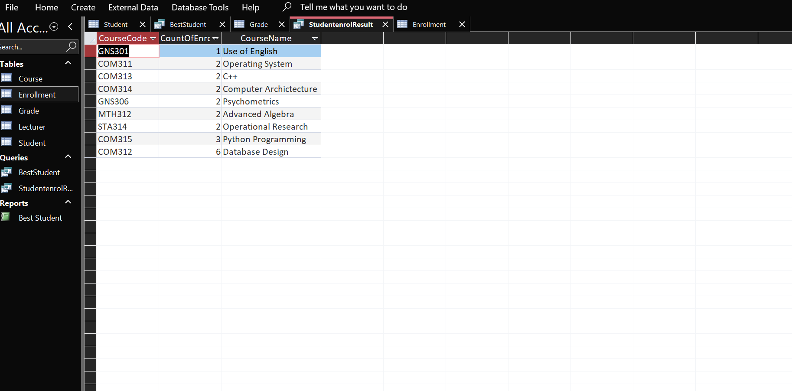

**Name:**

**Matric:**

**Course:**

**Query for Best Student in COM 312**

Design View

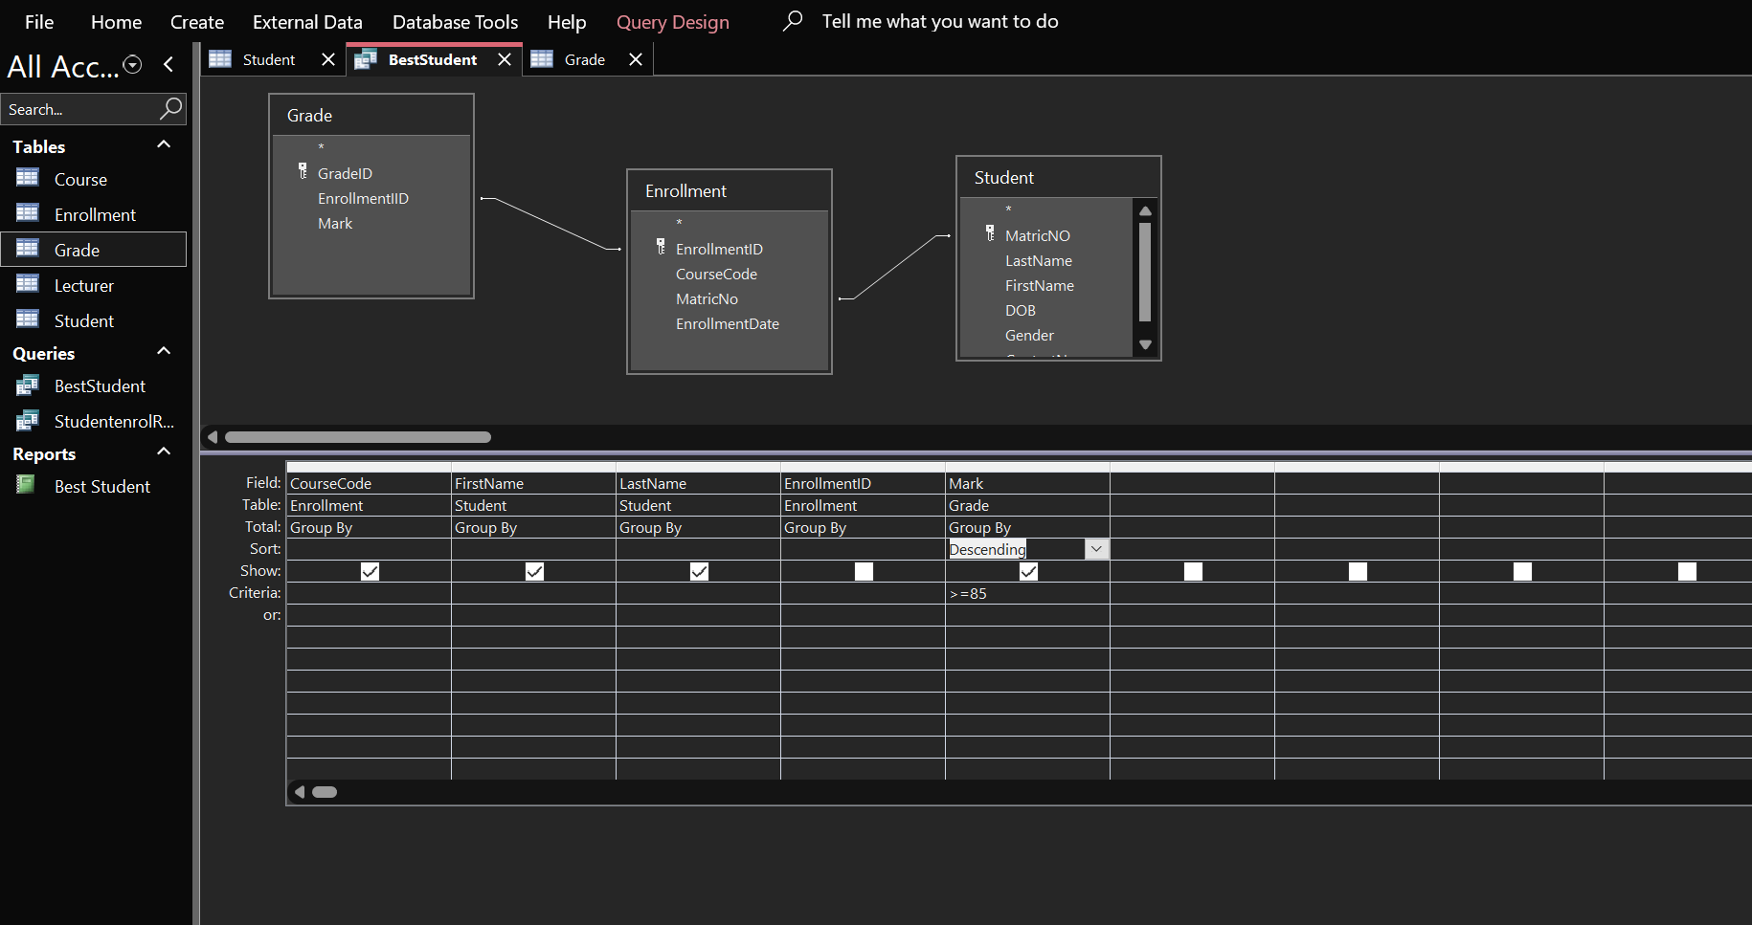

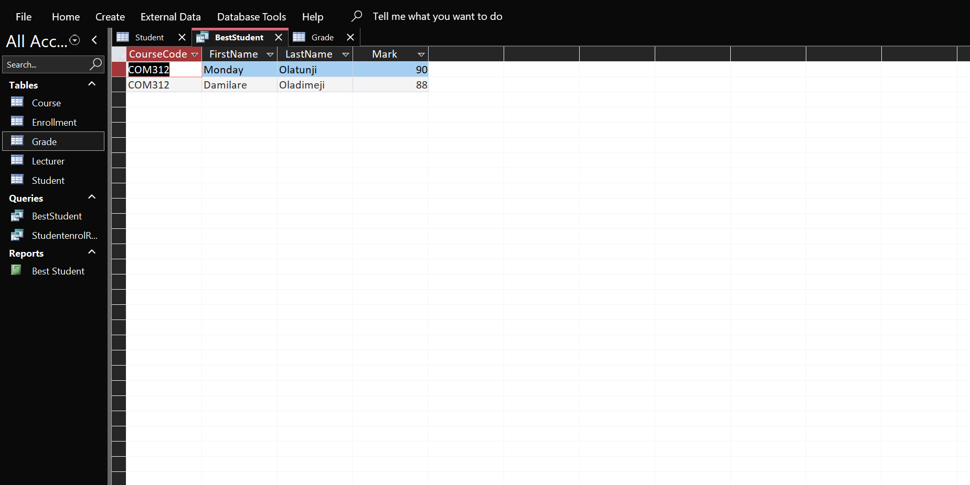Datasheet View (Output)